Si
gamma-ray | geometry 1 | geometry 3
1,16 | no peak | no peak
2,09
3,54 | 7,8 | 7
3,66 | no peak | no peak
4,93 | 6,15 | 5,23
6,38 | no peak | no peak
7,2 | 1,6 | no peak
K
gamma-ray
0,77 | no peak | no peak
Ca
gamma-ray
1,94 | 3 | 2,84
4,42 | 8,9 | 7,16
6,42 | 3,8 | 3,7

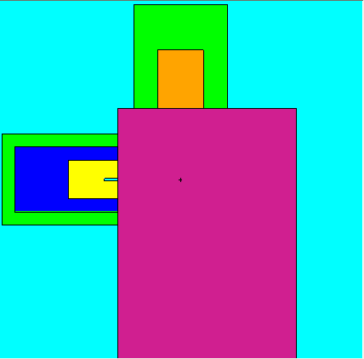
Si
Si
Ca
Ca
Ca

