Quick Introduction to MS Visual C++ 6.0
The following pages provide a quick tutorial on using Microsoft Visual C++ 6.0 to produce a small project. There should be no major differences if you are using version 5.0. The document was produced based on the document on http://ei.cs.vt.edu/~cs1205/

Getting Started: MS Visual C++ 6.0
To start Microsoft Visual C++ select Menu Start, Programs, Microsoft Visual Studio 6.0, Microsoft Visual C++ 6.0. You should now see a screen that looks similar to this:
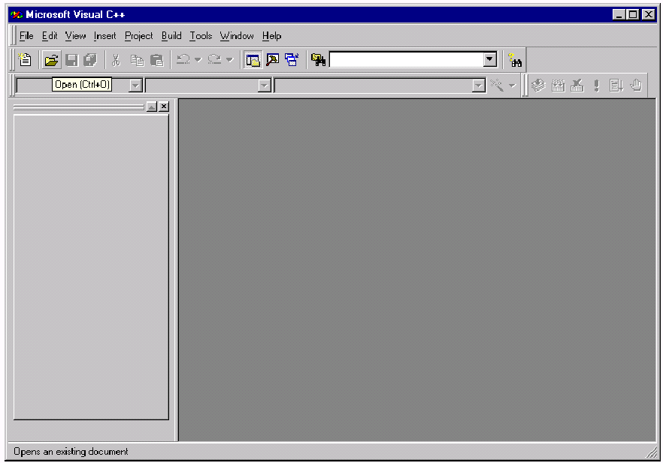

Creating a Project
Before you can begin coding, you must create a new workspace and project. To do so, go to the File menu and select New. You should see a dialog as shown below. Choose the Location of the project.
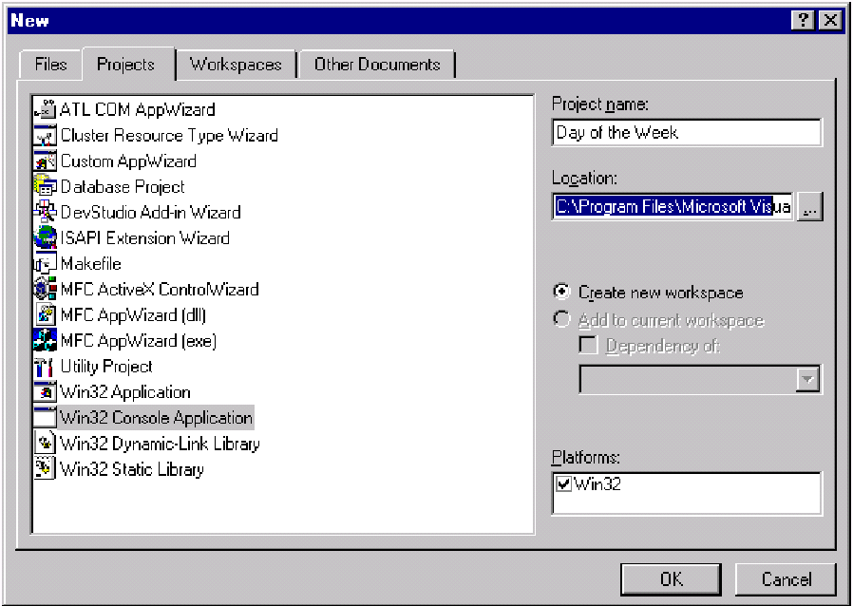
Project Wizard
After clicking Ok from the New project dialog window you will be presented with the project creation wizard “Win32 Console Application” dialog window as shown below:
Select an empty project and click Finish.
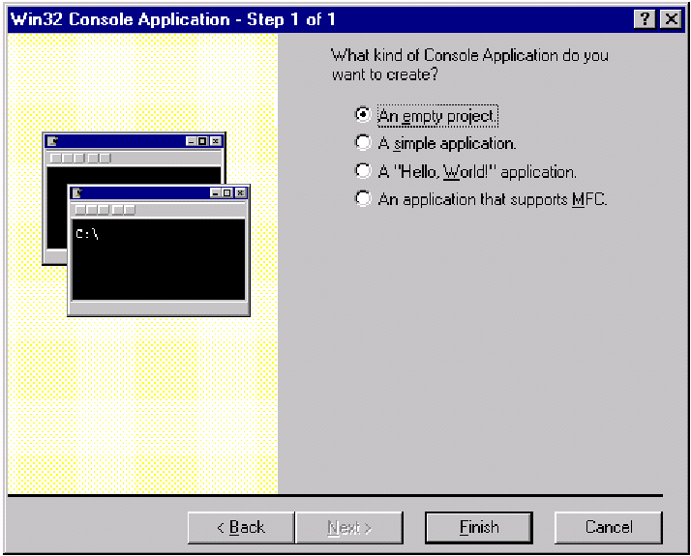
New Project Information
After clicking Finish from the “Win32 Console Application” dialog window a New Project Information window will simply explain no files were automatically generated. Click Ok to continue.
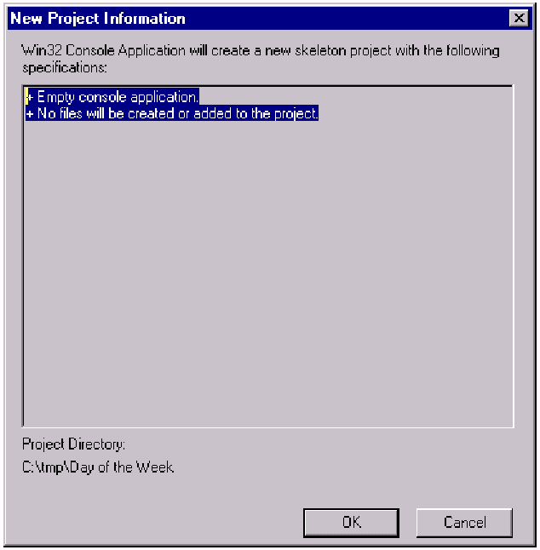
Creating a Project (continued)
If in the New Dialog Box: You selected Win32 Console Application (this will create an application that runs at the command prompt [like DOS]). In the Project Name textfield, you named your project Day of the Week. In the Location textfield, you typed the directory in which you wished to store your code files. After clicking OK, you should see a screen that looks similar to this:
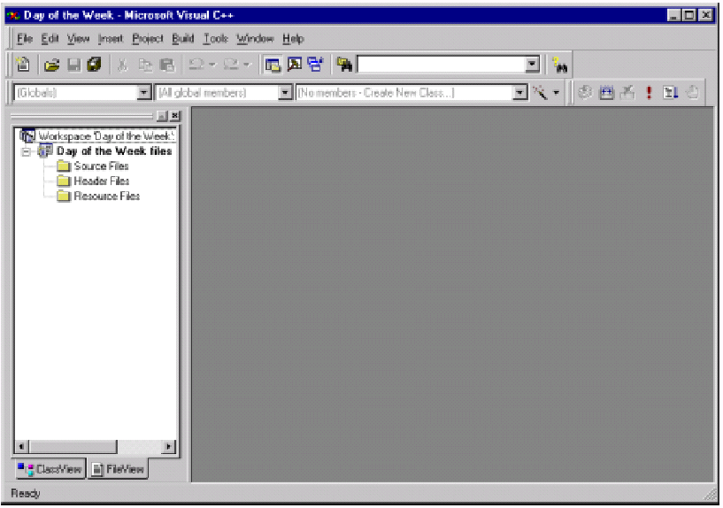
Creating a Code File
New Source Code File: Now that you have created a Project, you can add source code to it. To do so, go to the Project menu, select Add to Project, then New. You should see the following:
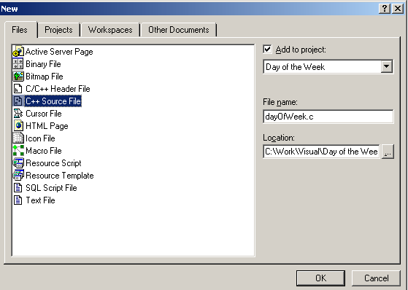
Important:
dayOfWeek file should have extension c (dayOfWeek.c)
Creating a Code File (continued)
Project + Source Code File: Click on C/C++ Source File. In the File Name textfield, type dayOfWeek. Click OK. You should now see a screen that looks similar to this:
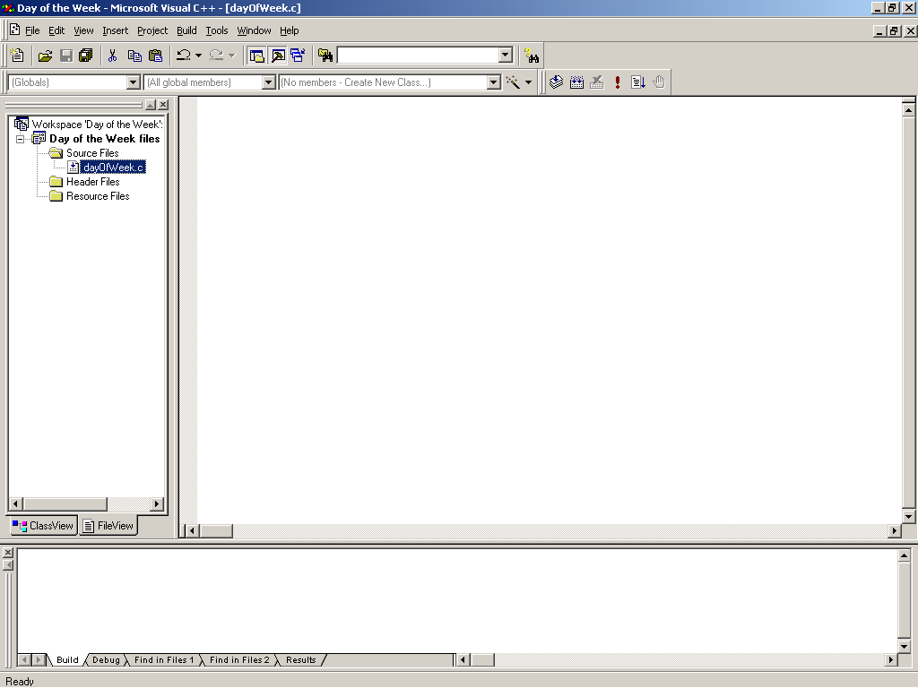
Sample Code
Now in the edit window that just appeared type in the following C++ source code:
#include <stdio.h>
#include <stdlib.h>
int main() //Find the Day of the Week for a Date
{
int mon, day, year;
printf("Enter a date for which you wish to know\n");
printf("the day of the week (MM DD YYYY)? ");
scanf("%d %d %d",&month,&day,&year);
if (year < 1752)
printf("Only Gregorian dates accepted, sorry \n");
else
{
if (month < 3)
{ //Jan & Feb = 13 & 14 preceding year
month += 12;
year -= 1;
{ // end if
weekDay = (day + 2*month + 3*(month+1)/5 + year +
year/4 - year/100 + year/400 + 1) % 7;
if (month > 12)
{ //reset Jan & Feb
month -= 12;
year += 1 ;
} // end if
printf("%d/%d/%d falls on",month,day,year);
switch (weekday)
{
case 0: prinf("Sunday\n"); break;
case 1: printf("Monday\n"); break;
case 2: printf("Tuesday\n"); break;
case 3: printf("Wednesday\n"); break;
case 4: printf("Thursday\n"); break;
case 5: printf("Friday\n"); break;
case 6: printf("Saturday\n"); break;
case 7: printf("Sunday\n"); break;
} // end switch
} // end else
return 0;
} // end main
Code Window
Now that you have entered all of your source code, you should have a window that looks like:
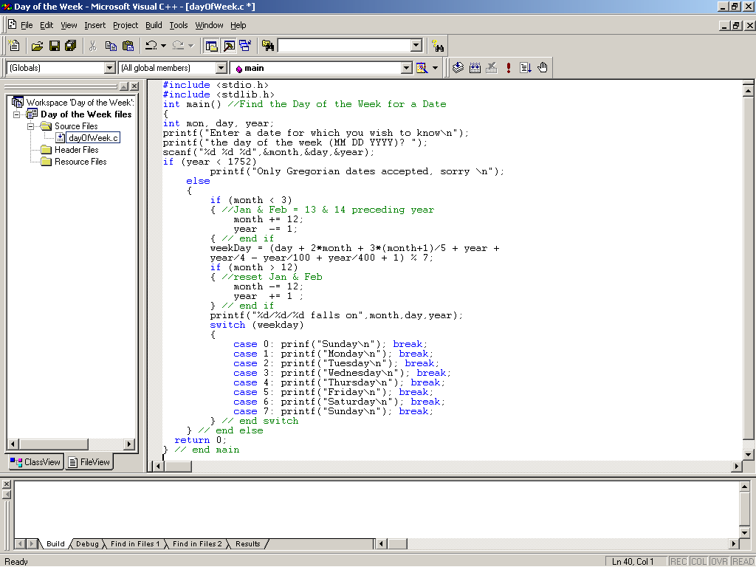
Building an Executable (Compilation)
You can now attempt to build your project. Building involves compiling and linking into an executable. Attempt to build the project, by hitting F7 or from the Build menu, select Build Day of he Week:
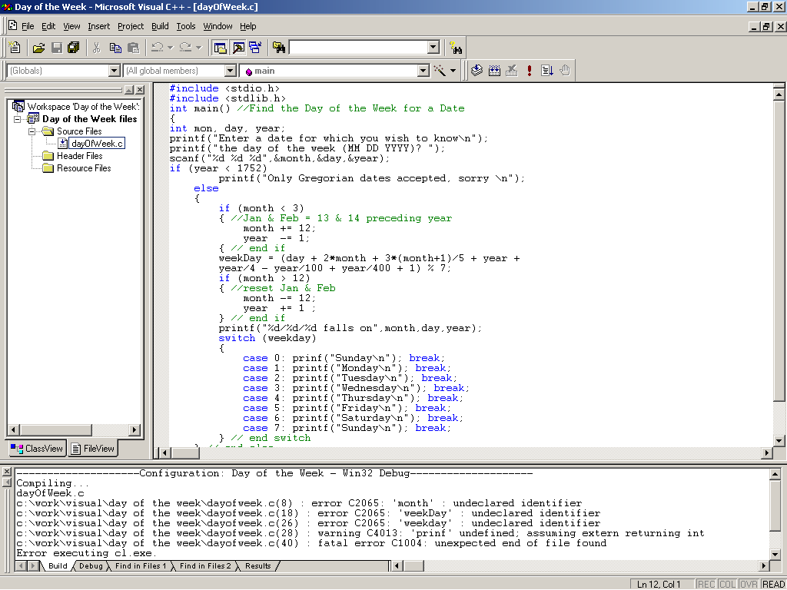
Error Messages (Finding Errors)
Notice the compiler error messages in the lower window. Double click on an error message, and the line with the error will be indicated in the code window:
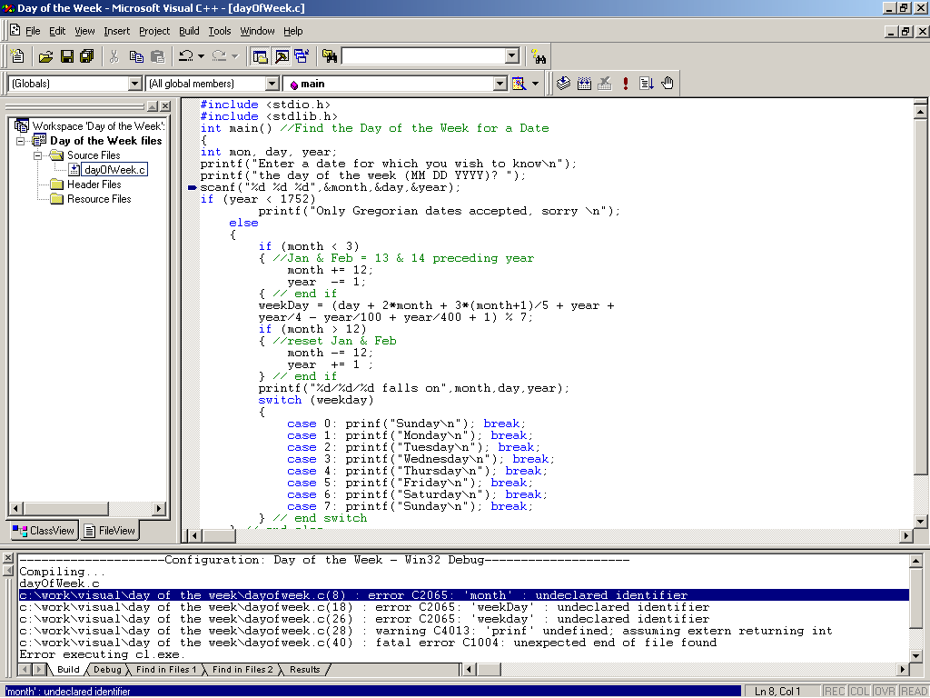
Correcting Errors
Compilation Errors
Now correct the errors relating to line 8 and build the project again:
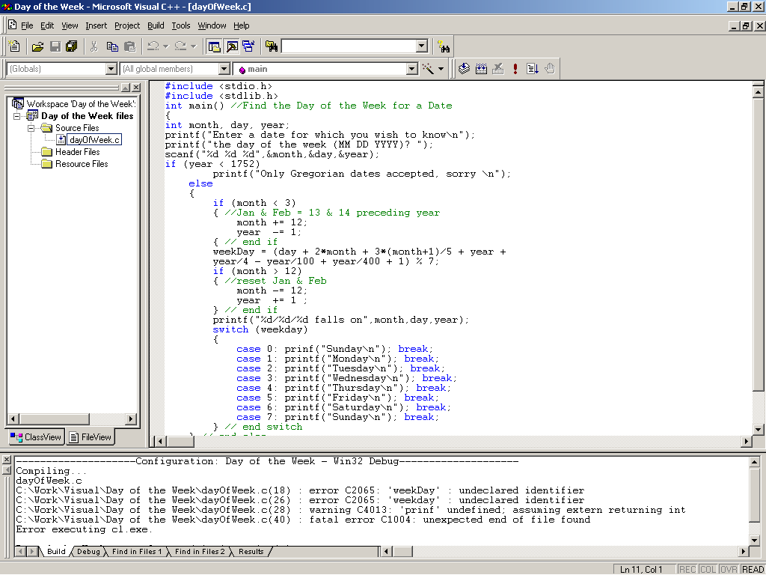
Error List
Error corrections:
In case you can’t figure out the errors here they are:
Line 8: change mon to month
add the variable weekDay
Line 17: change the { to } (we want to end the block, not start one)
Line 26: change weekDay to weekday to match the declaration
Line 28: change prinf to printf
Continue correcting errors and rebuilding until you have no errors:

Clean Compilation
No Errors
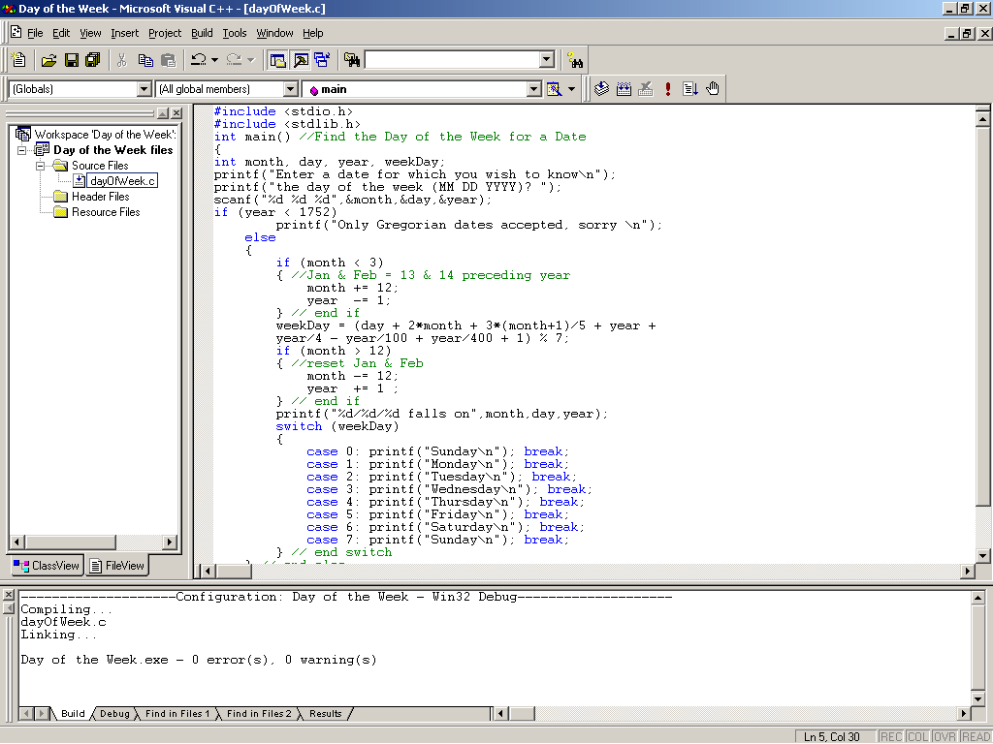
Running a Program
Program Execution
Now that your code has been compiled into an executable, it is ready to be executed. You can do so by pressing <Ctrl F5> or going to the Build menu and selecting Execute Day of the Week.exe Now you should see a DOS prompt with the program running:
